

**ATSS’s**

**Institute of Industrial and Computer Management and Research, Nigdi Pune**

**MCA Department**

**Academic Year: 2023-24**

**Practical Journal on**

**IT31L- Mobile Application Development**

**(SEM-III)**

**Submitted By:**

Student Name :

Roll No :

Seat No.:

**Date:**

**Course Outcome:**

Student will be able to :

CO1: Develop mobile application. (Apply)

**ATSS’s**

**Institute of Industrial and Computer Management and Research, Nigdi Pune**

**MCA Department**

# INDEX

**Students Name : Roll No.**

|  |  |  |  |  |  |
| --- | --- | --- | --- | --- | --- |
| **Sr.**  **No** | **Program Title** | **Course Outcome** | **Page No.** | **Teacher’s**  **Sign with Date** | **Remarks** |
| **1.** | Create a rating bar application, where user will rate a product. Display the rating using Toast. | **CO1** |  |  |  |
| **2.** | Create an app to accept package delivery method from given radio button options. On Clicking of button, display the selected option using Toast. | **CO1** |  |  |  |
| **3.** | Write a code to display “Do you want to close this application? “AlertDialog box. If user clicks on Yes, close the application and if clicks No, display “you choose no action for alertbox” message | **CO1** |  |  |  |
| **4.** | Create an option menu with Icons. On selecting any option from menu, display a proper toast message. | **CO1** |  |  |  |
| **5.** | Create following application using ContextMenu. When user long clicks on name, display menu options as Call, SMS. As per the option selected, display proper message. | **CO1** |  |  |  |
| **6.** | Write an application to accept a favourite programming language from user. Autocomplete the answer by using  AutoCompleteTextView & ArrayAdapter | **CO1** |  |  |  |
| **7.** | Write an android code to turn ON /OFF the Wi-  Fi. | **CO1** |  |  |  |
| **8.** | Create a fragment that has its own UI and enable your activities to communicate with fragments. | **CO1** |  |  |  |
| **9.** | Create an application using two activities. In first activity- accept user name, pass the same to next activity & display a “Hello & Welcome <username>” using Intent. | **CO1** |  |  |  |
| **10**. | Write an android code to make a phone call using Intent. | **CO1** |  |  |  |
| **11.** | Write an android application using SQLite to create table and perform CRUD operations Consider a COURSE table with fields C_ID,  C_Name, C_Duration, C_Description, perform ADD, UPDATE, DELETE and READ operations. | **CO1** |  |  |  |
| **12.** | Create an Android app to manage STUDENT data, powered by Firebase Realtime database that supports: Adding Data to Firebase Realtime database, Retrieving Data from Firebase, Update a record and Deleting data from firebase data. | **CO1** |  |  |  |
| **13.** | Write an android app to write JSON data into a file and read JSON data from created file. | **CO1** |  |  |  |
| **14.** | Write a React Native application, to display a welcome screen with ‘Welcome to React Native’ message. | **CO1** |  |  |  |
| **15.** | Write a Flutter application, to display a ‘Hello World’ message. | **CO1** |  |  |  |

Q1. Create a rating bar application, where user will rate a product. Display the rating using Toast.

#MainActivity.java

import android.support.v7.app.AppCompatActivity;

import android.os.Bundle;

import android.view.View;

import android.widget.Button;

import android.widget.RatingBar;

import android.widget.Toast;

public class MainActivity extends AppCompatActivity {

    private RatingBar ratingBar;

    private Button submitButton;

    @Override

    protected void onCreate(Bundle savedInstanceState) {

        super.onCreate(savedInstanceState);

        setContentView(R.layout.activity_main);

        ratingBar = findViewById(R.id.ratingBar);

        submitButton = findViewById(R.id.submitButton);

    }

    public void submitRating(View view) {

        float rating = ratingBar.getRating();

        String message = "Rating: " + rating;

        Toast.makeText(this, message, Toast.LENGTH_SHORT).show();

    }

}

#Acticity_Main.xml

<?xml version="1.0" encoding="utf-8"?>

<RelativeLayout xmlns:android="http://schemas.android.com/apk/res/android"

    xmlns:tools="http://schemas.android.com/tools"

    android:layout_width="match_parent"

    android:layout_height="match_parent"

    tools:context=".MainActivity">

    <RatingBar

        android:id="@+id/ratingBar"

        android:layout_width="wrap_content"

        android:layout_height="wrap_content"

        android:layout_centerInParent="true"

        android:numStars="5"

      android:stepSize="1.0" />

    <Button

        android:id="@+id/submitButton"

        android:layout_width="wrap_content"

        android:layout_height="wrap_content"

        android:layout_below="@id/ratingBar"

        android:layout_centerHorizontal="true"

        android:layout_marginTop="16dp"

        android:text="Submit Rating"

        android:onClick="submitRating"/>

</RelativeLayout>

        android:layout_weight="1"

            android:layout_height="wrap_content"

            android:layout_weight="1"

            android:onClick="performOperation"

            android:text="-" />

        <Button

            android:id="@+id/buttonMultiply"

            android:layout_width="0dp"

            android:layout_height="wrap_content"

            android:layout_weight="1"

            android:onClick="performOperation"

            android:text="*" />

    </LinearLayout>

Output:

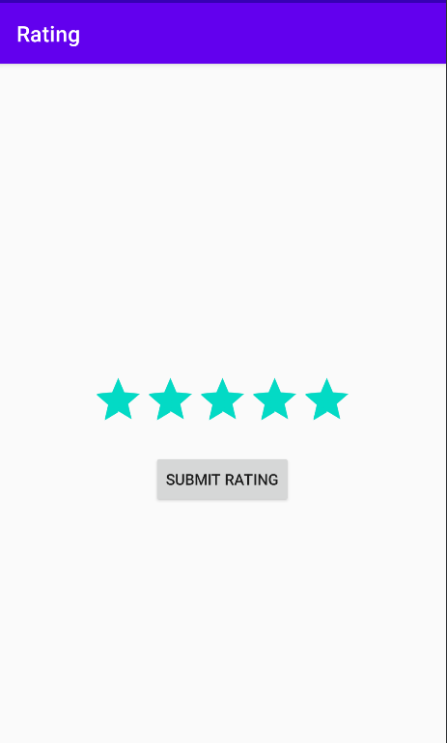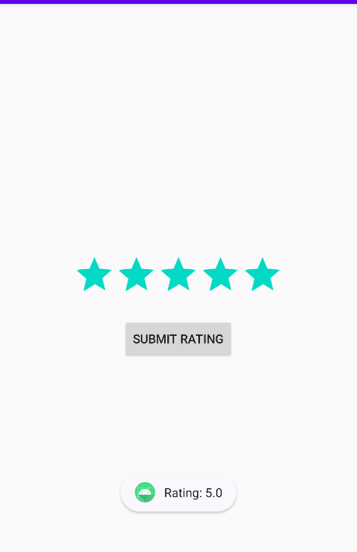

Q2. Create an app to accept package delivery method from given radio button options Same day, Next day, Pickup. On Clicking of any of the radio button, display the selected option using Toast.

#MainActivity.java

import androidx.appcompat.app.AppCompatActivity;

import android.os.Bundle;

import android.view.View;

import android.widget.Button;

import android.widget.RadioButton;

import android.widget.RadioGroup;

import android.widget.Toast;

public class MainActivity extends AppCompatActivity {

    private RadioGroup radioGroup;

    private Button submitButton;

    @Override

    protected void onCreate(Bundle savedInstanceState) {

        super.onCreate(savedInstanceState);

        setContentView(R.layout.activity_main);

        radioGroup = findViewById(R.id.radioGroup);

        submitButton = findViewById(R.id.submitButton);

    }

        public void submitDeliveryMethod(View view) {

            int selectedId = radioGroup.getCheckedRadioButtonId();

            if (selectedId != -1) {

                RadioButton selectedRadioButton = findViewById(selectedId);

                String selectedOption = selectedRadioButton.getText().toString();

                String message = "Selected Delivery Method: " + selectedOption;

                Toast.makeText(this, message, Toast.LENGTH_SHORT).show();

            } else {

                Toast.makeText(this, "Please select a delivery method", Toast.LENGTH_SHORT).show();

            }

    }

}

#Acticity_Main.xml

<?xml version="1.0" encoding="utf-8"?>

<RelativeLayout xmlns:android="http://schemas.android.com/apk/res/android"

    xmlns:tools="http://schemas.android.com/tools"

    android:layout_width="match_parent"

    android:layout_height="match_parent"

    tools:context=".MainActivity">

    <RadioGroup

        android:id="@+id/radioGroup"

        android:layout_width="wrap_content"

        android:layout_height="wrap_content"

        android:layout_centerInParent="true">

        <RadioButton

            android:id="@+id/radioSameDay"

            android:layout_width="wrap_content"

            android:layout_height="wrap_content"

            android:text="Same Day"/>

        <RadioButton

            android:id="@+id/radioNextDay"

            android:layout_width="wrap_content"

            android:layout_height="wrap_content"

            android:text="Next Day"/>

        <RadioButton

            android:id="@+id/radioPickup"

            android:layout_width="wrap_content"

            android:layout_height="wrap_content"

            android:text="Pickup"/>

    </RadioGroup>

    <Button

        android:id="@+id/submitButton"

        android:layout_width="wrap_content"

        android:layout_height="wrap_content"

        android:layout_below="@id/radioGroup"

        android:layout_centerHorizontal="true"

        android:layout_marginTop="16dp"

        android:text="Submit"

        android:onClick="submitDeliveryMethod"/>

</RelativeLayout>

Output:

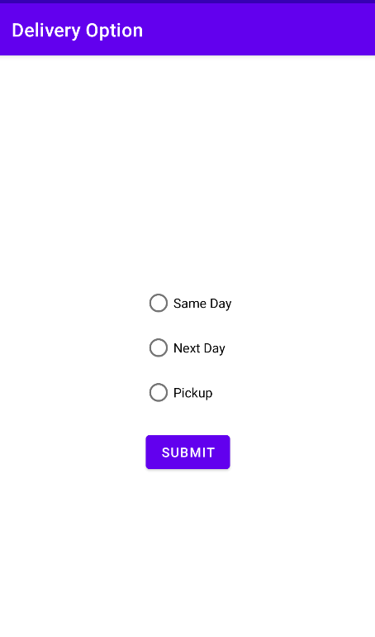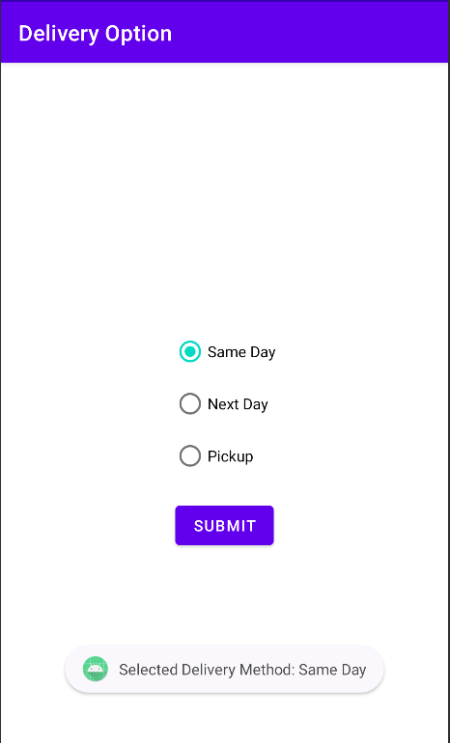

Q.3. Write a code to display “Do you want to close this application? “AlertDialog box. If user clicks on Yes, close the application and if clicks No, display “you choose no action for alertbox” message.

//MainActivity.java

package com.example.appclosealertbox;

import android.app.AlertDialog;

import android.content.DialogInterface;

import android.os.Bundle;

import android.view.View;

import android.widget.Button;

import android.widget.Toast;

import androidx.appcompat.app.AppCompatActivity;

public class MainActivity extends AppCompatActivity {

@Override

protected void onCreate(Bundle savedInstanceState) {

super.onCreate(savedInstanceState);

setContentView(R.layout.activity_main);

// Replace with the ID of your button in activity_main.xml

Button closeAppButton = findViewById(R.id.closeAppButton);

// Set a click listener for the button

closeAppButton.setOnClickListener(new View.OnClickListener() {

@Override

public void onClick(View view) {

showCloseAlertDialog();

}

});

}

private void showCloseAlertDialog() {

AlertDialog.Builder builder = new AlertDialog.Builder(this);

builder.setTitle("Close Application")

.setMessage("Do you want to close this application?")

.setPositiveButton("Yes", new DialogInterface.OnClickListener() {

@Override

public void onClick(DialogInterface dialogInterface, int i) {

closeApplication();

}

})

.setNegativeButton("No", new DialogInterface.OnClickListener() {

@Override

public void onClick(DialogInterface dialogInterface, int i) {

displayNoActionMessage();

}

})

.show();

}

private void closeApplication() {

// Close the application

finish();

}

private void displayNoActionMessage() {

// Display a message when the user chooses "No"

// You can replace this with any action you want to perform

// when the user decides not to close the application

showToast("You chose no action for alert box");

}

private void showToast(String message) {

Toast.makeText(this, message, Toast.LENGTH_SHORT).show();

}

}

//activity_main.xml

<?xml version="1.0" encoding="utf-8"?>

<RelativeLayout xmlns:android="http://schemas.android.com/apk/res/android"

xmlns:tools="http://schemas.android.com/tools"

android:layout_width="match_parent"

android:layout_height="match_parent"

android:paddingLeft="16dp"

android:paddingTop="16dp"

android:paddingRight="16dp"

android:paddingBottom="16dp"

tools:context=".MainActivity">

<Button

android:id="@+id/closeAppButton"

android:layout_width="wrap_content"

android:layout_height="wrap_content"

android:text="Close App"

android:layout_centerInParent="true"/>

</RelativeLayout>

Output:

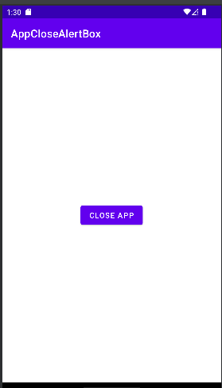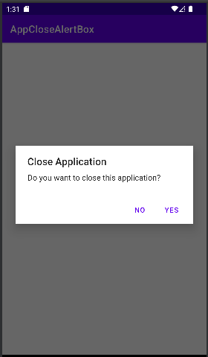

Q.4. Create an option menu with Icons. On selecting any option from menu, display a proper toast message.

//MainActivity.java

package com.example.menu_with_icons;

import android.os.Bundle;

import android.view.Menu;

import android.view.MenuItem;

import android.widget.Toast;

import androidx.annotation.NonNull;

import androidx.appcompat.app.AppCompatActivity;

public class MainActivity extends AppCompatActivity {

@Override

protected void onCreate(Bundle savedInstanceState) {

super.onCreate(savedInstanceState);

setContentView(R.layout.activity_main);

// Other initialization code goes here

}

@Override

public boolean onCreateOptionsMenu(Menu menu) {

getMenuInflater().inflate(R.menu.menu_main, menu);

return true;

}

@Override

public boolean onOptionsItemSelected(@NonNull MenuItem item) {

switch (item.getItemId()) {

case R.id.menu_call:

showToast(getString(R.string.menu_call) + " option selected");

return true;

case R.id.menu_sms:

showToast(getString(R.string.menu_sms) + " option selected");

return true;

default:

return super.onOptionsItemSelected(item);

}

}

private void showToast(String message) {

Toast.makeText(this, message, Toast.LENGTH_SHORT).show();

}

}

//activity_main.xml

<?xml version="1.0" encoding="utf-8"?>

<RelativeLayout xmlns:android="http://schemas.android.com/apk/res/android"

xmlns:tools="http://schemas.android.com/tools"

android:layout_width="match_parent"

android:layout_height="match_parent"

android:padding="16dp"

tools:context=".MainActivity">

<TextView

android:id="@+id/textView"

android:layout_width="wrap_content"

android:layout_height="wrap_content"

android:text="Hello, World!" />

<!-- Other UI elements can be added here -->

</RelativeLayout>

**//menu_main.xml**

<?xml version="1.0" encoding="utf-8"?>

<menu xmlns:android="http://schemas.android.com/apk/res/android">

<item

android:id="@+id/menu_call"

android:icon="@drawable/ic_call"

android:title="@string/menu_call" />

<item

android:id="@+id/menu_sms"

android:icon="@drawable/ic_sms"

android:title="@string/menu_sms" />

</menu>

Output:

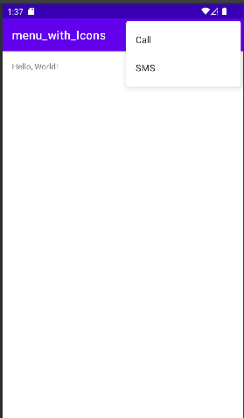

Q.5. Create following application using ContextMenu. When user long clicks on name, display menu options as Call, SMS. As per the option selected, display proper message.

//MainActivity.java

package com.example.contextmenu;

import android.os.Bundle;

import android.view.ContextMenu;

import android.view.MenuInflater;

import android.view.MenuItem;

import android.view.View;

import android.widget.TextView;

import android.widget.Toast;

import androidx.appcompat.app.AppCompatActivity;

public class MainActivity extends AppCompatActivity {

private TextView nameTextView;

@Override

protected void onCreate(Bundle savedInstanceState) {

super.onCreate(savedInstanceState);

setContentView(R.layout.activity_main);

nameTextView = findViewById(R.id.nameTextView);

// Register the view for context menu

registerForContextMenu(nameTextView);

}

@Override

public void onCreateContextMenu(ContextMenu menu, View v, ContextMenu.ContextMenuInfo menuInfo) {

super.onCreateContextMenu(menu, v, menuInfo);

// Inflate the menu from the XML resource

MenuInflater inflater = getMenuInflater();

inflater.inflate(R.menu.context_menu, menu);

}

@Override

public boolean onContextItemSelected(MenuItem item) {

switch (item.getItemId()) {

case R.id.menu_call:

displayMessage("Calling " + nameTextView.getText().toString());

return true;

case R.id.menu_sms:

displayMessage("Sending SMS to " + nameTextView.getText().toString());

return true;

default:

return super.onContextItemSelected(item);

}

}

private void displayMessage(String message) {

Toast.makeText(this, message, Toast.LENGTH_SHORT).show();

}

}

//activity_main.xml

<?xml version="1.0" encoding="utf-8"?>

<RelativeLayout xmlns:android="http://schemas.android.com/apk/res/android"

xmlns:tools="http://schemas.android.com/tools"

android:layout_width="match_parent"

android:layout_height="match_parent"

android:padding="16dp"

tools:context=".MainActivity">

<TextView

android:id="@+id/nameTextView"

android:layout_width="wrap_content"

android:layout_height="wrap_content"

android:text="John Doe"

android:textSize="24sp"

android:longClickable="true"/>

</RelativeLayout>

//context_menu.xml

<menu xmlns:android="http://schemas.android.com/apk/res/android">

<item

android:id="@+id/menu_call"

android:title="Call" />

<item

android:id="@+id/menu_sms"

android:title="SMS" />

</menu>

Output:

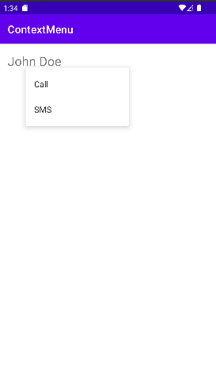

Q.6. Write an android code to accept fav programming language from user. Autocomplete the answer by using autocomplete textview and arrayAdapter

Activity_main.xml

<?xml version="1.0" encoding="utf-8"?>  
<androidx.constraintlayout.widget.ConstraintLayout xmlns:android="http://schemas.android.com/apk/res/android"  
 xmlns:app="http://schemas.android.com/apk/res-auto"  
 xmlns:tools="http://schemas.android.com/tools"  
 android:layout_width="match_parent"  
 android:layout_height="match_parent"  
 tools:context=".MainActivity">  
  
  
 <TextView  
 android:id="@+id/textView"  
 android:layout_width="wrap_content"  
 android:layout_height="wrap_content"  
 android:layout_marginTop="120dp"  
 android:text="Fav Programming Language"  
 app:layout_constraintEnd_toEndOf="parent"  
 app:layout_constraintHorizontal_bias="0.553"  
 app:layout_constraintStart_toStartOf="parent"  
 app:layout_constraintTop_toTopOf="parent" />  
  
 <AutoCompleteTextView  
 android:id="@+id/autoCompleteTextView"  
 android:layout_width="match_parent"  
 android:layout_height="wrap_content"  
 android:layout_marginTop="204dp"  
 android:hint="Type fav language"  
 app:layout_constraintEnd_toEndOf="parent"  
 app:layout_constraintHorizontal_bias="0.599"  
 app:layout_constraintStart_toStartOf="parent"  
 app:layout_constraintTop_toBottomOf="@+id/textView" />  
</androidx.constraintlayout.widget.ConstraintLayout>

MainActivity.java

package com.example.favprogramming;  
  
import androidx.appcompat.app.AppCompatActivity;  
  
import android.os.Bundle;  
import android.widget.ArrayAdapter;  
import android.widget.AutoCompleteTextView;  
  
public class MainActivity extends AppCompatActivity {  
 String[] language={"C","C++","Java",".NET","JavaScript","Android","ASP.NET","PHP","C#"};  
 @Override  
 protected void onCreate(Bundle savedInstanceState) {  
 super.onCreate(savedInstanceState);  
 setContentView(R.layout.*activity_main*);  
  
 ArrayAdapter<String> adapter = new ArrayAdapter<String> (this,android.R.layout.*select_dialog_item*,language);  
 AutoCompleteTextView actv = (AutoCompleteTextView)findViewById(R.id.*autoCompleteTextView*); actv.setThreshold(1);  
 actv.setAdapter(adapter);  
  
 }  
}

Output:

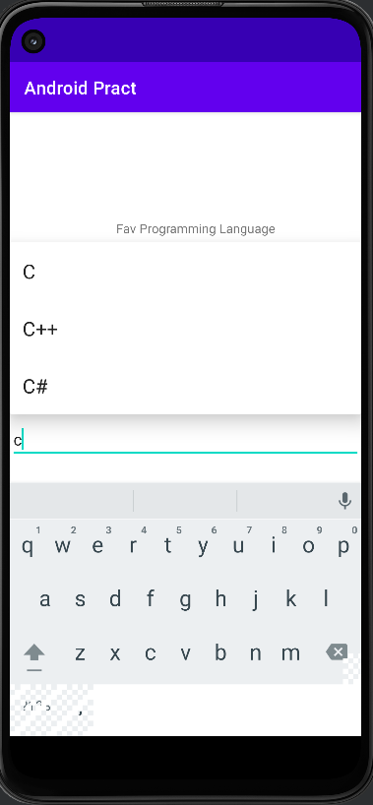

Q.7. Write an android code to turn ON /OFF the Wi-Fi#MainActivity.java

// MainActivity.java

import android.content.Context;

import android.content.pm.PackageManager;

import android.net.wifi.WifiManager;

import android.os.Build;

import android.os.Bundle;

import android.view.View;

import android.widget.Button;

import android.widget.Toast;

import androidx.annotation.NonNull;

import androidx.appcompat.app.AppCompatActivity;

import androidx.core.app.ActivityCompat;

import androidx.core.content.ContextCompat;

public class MainActivity extends AppCompatActivity {

    private static final int PERMISSIONS_REQUEST_CODE = 100;

    private Button btnToggleWifi;

    private WifiManager wifiManager;

    @Override

    protected void onCreate(Bundle savedInstanceState) {

        super.onCreate(savedInstanceState);

        setContentView(R.layout.activity_main);

        btnToggleWifi = findViewById(R.id.btnToggleWifi);

        wifiManager = (WifiManager) getSystemService(Context.WIFI_SERVICE);

        checkAndRequestPermissions();

        btnToggleWifi.setOnClickListener(new View.OnClickListener() {

            @Override

            public void onClick(View v) {

                toggleWifi();

            }

        });

    }

    private void checkAndRequestPermissions() {

        if (Build.VERSION.SDK_INT >= Build.VERSION_CODES.M) {

            if (ContextCompat.checkSelfPermission(this, android.Manifest.permission.CHANGE_WIFI_STATE) != PackageManager.PERMISSION_GRANTED ||

                    ContextCompat.checkSelfPermission(this, android.Manifest.permission.ACCESS_WIFI_STATE) != PackageManager.PERMISSION_GRANTED) {

                ActivityCompat.requestPermissions(this,

                        new String[]{

                                android.Manifest.permission.CHANGE_WIFI_STATE,

                                android.Manifest.permission.ACCESS_WIFI_STATE

                        },

                        PERMISSIONS_REQUEST_CODE);

            }

        }

    }

    private void toggleWifi() {

        if (wifiManager != null) {

            if (wifiManager.isWifiEnabled()) {

                wifiManager.setWifiEnabled(false);

                showToast("Wi-Fi turned OFF");

            } else {

                wifiManager.setWifiEnabled(true);

                showToast("Wi-Fi turned ON");

            }

        }

    }

    private void showToast(String message) {

        Toast.makeText(this, message, Toast.LENGTH_SHORT).show();

    }

    @Override

    public void onRequestPermissionsResult(int requestCode, @NonNull String[] permissions, @NonNull int[] grantResults) {

        super.onRequestPermissionsResult(requestCode, permissions, grantResults);

        if (requestCode == PERMISSIONS_REQUEST_CODE) {

            if (grantResults.length > 0 && grantResults[0] == PackageManager.PERMISSION_GRANTED) {

                // Permissions granted, you can proceed with your actions

            } else {

                // Permissions not granted, inform the user or handle it gracefully

                showToast("Permissions required to toggle Wi-Fi.");

            }

        }

    }

}

#Activity_Main.xml

<?xml version="1.0" encoding="utf-8"?>

<RelativeLayout

    xmlns:android="http://schemas.android.com/apk/res/android"

    android:layout_width="match_parent"

    android:layout_height="match_parent"

    android:padding="16dp">

    <Button

        android:id="@+id/btnToggleWifi"

        android:layout_width="wrap_content"

        android:layout_height="wrap_content"

        android:text="Toggle Wi-Fi"

        android:layout_centerInParent="true"/>

</RelativeLayout>

#Android_Manifest

<uses-permission android:name="android.permission.CHANGE_WIFI_STATE" />

<uses-permission android:name="android.permission.ACCESS_WIFI_STATE" />

Output:

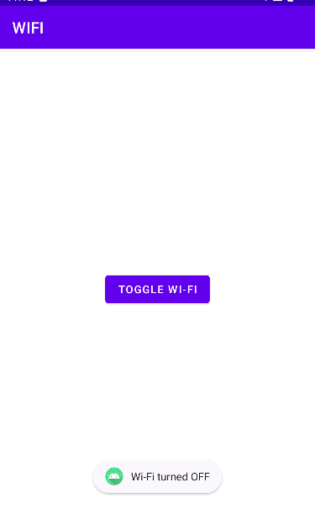

Q.8. Create a fragment that has its own UI and enable your activities to communicate with fragments.

#FirstFragment.java

import android.os.Bundle;

import android.view.LayoutInflater;

import android.view.View;

import android.view.ViewGroup;

import androidx.annotation.NonNull;

import androidx.annotation.Nullable;

import androidx.fragment.app.Fragment;

import com.abhishek.fragmentactivity.R;

public class FirstFragment extends Fragment {

    @Nullable @Override

public View onCreateView(@NonNull LayoutInflater inflater, @Nullable ViewGroup container, @Nullable Bundle savedInstanceState) {

    //return super.onCreateView(inflater, container, savedInstanceState);

    return inflater.inflate(R.layout.first_fragment,container,false);

    }

}

#SecondFragment.java

import android.os.Bundle;

import android.view.LayoutInflater;

import android.view.View;

import android.view.ViewGroup;

import androidx.annotation.NonNull;

import androidx.annotation.Nullable;

import androidx.fragment.app.Fragment;

import com.abhishek.fragmentactivity.R;

public class SecondFragment extends Fragment {

    @Nullable @Override

public View onCreateView(@NonNull LayoutInflater inflater, @Nullable ViewGroup container, @Nullable Bundle savedInstanceState) {

//return super.onCreateView(inflater, container, savedInstanceState);

    return inflater.inflate(R.layout.second_fragment,container,false);

}

}

#MainActivity.java

import androidx.appcompat.app.AppCompatActivity;

import android.content.Context;

import android.graphics.Color;

import android.net.wifi.WifiManager;

import android.os.Bundle;

import android.widget.ArrayAdapter;

import android.widget.AutoCompleteTextView;

import android.widget.CompoundButton;

import android.widget.TextView;

import android.widget.ToggleButton;

import androidx.fragment.app.Fragment;

 import android.view.View;

public class MainActivity extends AppCompatActivity {

    Fragment selectedFragment;

    @Override

protected void onCreate(Bundle savedInstanceState) {

        super.onCreate(savedInstanceState);

        setContentView(R.layout.activity_main);

}

    public void selectFragment(View view) {

        if (view == findViewById(R.id.button1)) {

        selectedFragment = new FirstFragment();

    } else if (view == findViewById(R.id.button2)) {

            selectedFragment = new SecondFragment();

    }

        getSupportFragmentManager().beginTransaction().replace(R.id.fragment_container, selectedFragment).commit();

    }

}

#firstFragment.xml

<?xml version="1.0" encoding="utf-8"?>

<androidx.constraintlayout.widget.ConstraintLayout

    xmlns:android="http://schemas.android.com/apk/res/android"

    android:layout_width="match_parent"

    android:layout_height="match_parent"

    xmlns:app="http://schemas.android.com/apk/res-auto">

    <TextView

        android:id="@+id/first"

        android:layout_width="match_parent"

        android:layout_height="wrap_content"

        android:text="Hello, First Fragment "

        android:textSize="30sp"

        android:gravity="center"

        app:layout_constraintBottom_toBottomOf="parent"

        app:layout_constraintEnd_toEndOf="parent"

        app:layout_constraintHorizontal_bias="0.5"

        app:layout_constraintStart_toStartOf="parent"

        app:layout_constraintTop_toTopOf="parent" />

</androidx.constraintlayout.widget.ConstraintLayout>

#SecondFragment.xml

<?xml version="1.0" encoding="utf-8"?>

<androidx.constraintlayout.widget.ConstraintLayout

    xmlns:android="http://schemas.android.com/apk/res/android"

    android:layout_width="match_parent"

    android:layout_height="match_parent"

    xmlns:app="http://schemas.android.com/apk/res-auto">

    <TextView

        android:id="@+id/first"

        android:layout_width="match_parent"

        android:layout_height="wrap_content"

        android:text="Hello, second Fragment"

        android:textSize="30sp"

        android:gravity="center"

        app:layout_constraintBottom_toBottomOf="parent"

        app:layout_constraintEnd_toEndOf="parent"

        app:layout_constraintHorizontal_bias="0.5"

        app:layout_constraintStart_toStartOf="parent"

        app:layout_constraintTop_toTopOf="parent" />

</androidx.constraintlayout.widget.ConstraintLayout>

#activity_main.xml

<?xml version="1.0" encoding="utf-8"?>

<LinearLayout xmlns:android="http://schemas.android.com/apk/res/android"

    xmlns:app="http://schemas.android.com/apk/res-auto"

    xmlns:tools="http://schemas.android.com/tools"

    android:layout_width="match_parent"

    android:layout_height="match_parent"

    android:orientation="vertical"

    tools:context=".MainActivity">

    <!-- Heading of the activity -->

    <TextView android:id="@+id/textView"

        android:layout_width="match_parent"

        android:layout_height="wrap_content"

        android:layout_marginTop="20dp"

        android:layout_marginBottom="20dp"

        android:text="@string/heading"

        android:textAlignment="center"

        android:textColor="@android:color/holo_green_light"

        android:textSize="24sp"

        android:textStyle="bold" />

    <!-- Button to display first fragment -->

    <Button android:id="@+id/button1"

        android:layout_width="fill_parent"

        android:layout_height="wrap_content"

        android:layout_margin="20dp"

        android:background="#4CAF50"

        android:onClick="selectFragment"

        android:text="@string/fragment1_button"

        android:textColor="@android:color/background_light"

        android:textSize="18sp"

        android:textStyle="bold" />

    <!-- Button to display second fragment -->

    <Button android:id="@+id/button2"

        android:layout_width="fill_parent"

        android:layout_height="wrap_content"

        android:layout_margin="20dp"

        android:background="#4CAF50"

        android:onClick="selectFragment"

        android:text="@string/fragment2_button"

        android:textColor="@android:color/background_light"

        android:textSize="18sp"

        android:textStyle="bold" />

    <!-- Adding Fragment element in the activity -->

    <FrameLayout

        android:id="@+id/fragment_container"

        android:layout_width="match_parent"

        android:layout_height="match_parent"

        />

</LinearLayout>

Output:

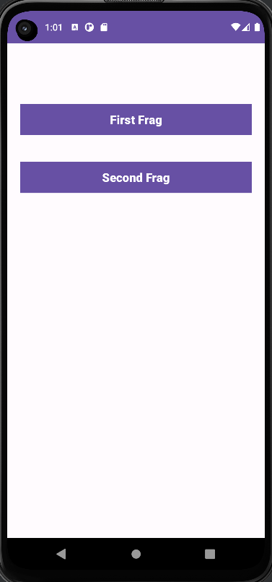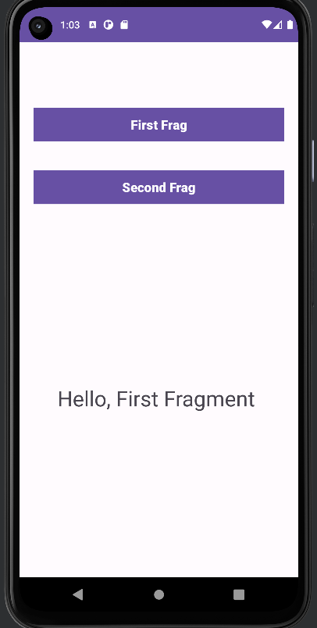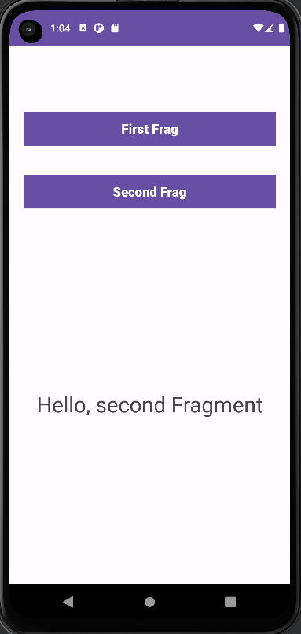

Q.9. Create an application using two activities. In first activity- accept user name, pass the same to next activity & display a “Hello & Welcome <username>” using Intent. Design proper UI.

#MainActivity.java

package com.abhishek.twoactivities;  
  
import androidx.appcompat.app.AppCompatActivity;  
import android.content.Intent;  
import android.os.Bundle;  
import android.view.View;  
import android.widget.EditText;  
public class MainActivity extends AppCompatActivity {  
 EditText uname;  
 @Override  
protected void onCreate(Bundle savedInstanceState) {  
 super.onCreate(savedInstanceState);  
 setContentView(R.layout.*activity_main*);  
}  
 public void callSecondActivity(View view) {  
 uname =(EditText) findViewById(R.id.*editText1*);  
 Intent intent=new Intent(this, SecondActivity.class);  
 intent.putExtra ("Value1", "Hello");  
 intent.putExtra ("Value2", uname.getText().toString());  
 startActivity(intent);  
 }  
}

#SecondActivity.java

package com.abhishek.twoactivities;  
import androidx.appcompat.app.AppCompatActivity;  
import android.content.Intent;  
import android.os.Bundle;  
import android.view.View;  
import android.widget.TextView;  
import android.widget.Toast;  
public class SecondActivity extends AppCompatActivity {  
 TextView t1;  
 @Override  
protected void onCreate(Bundle savedInstanceState) {  
 super.onCreate(savedInstanceState);  
 setContentView(R.layout.*activity_second*);  
 t1 = findViewById(R.id.*textView2*);  
 Bundle extras = getIntent().getExtras();  
 String value1 = extras.getString("Value1");  
 String value2 = extras.getString("Value2");  
 t1.setText(value1+ " "+value2);  
 Toast.*makeText* (getApplicationContext(), value1+ " "+value2, Toast.*LENGTH_LONG*).show();  
}  
 public void goBack(View view) {  
 Intent bintent=new Intent(this, MainActivity.class);  
 startActivity(bintent);  
 }  
}

#MainActivity.xml

<?xml version="1.0" encoding="utf-8"?>  
<RelativeLayout xmlns:android="http://schemas.android.com/apk/res/android"  
 xmlns:tools="http://schemas.android.com/tools"  
 android:layout_width="match_parent"  
 android:layout_height="match_parent"  
 tools:context=".MainActivity" >  
  
 <EditText  
 android:id="@+id/editText1"  
 android:layout_width="wrap_content"  
 android:layout_height="wrap_content"  
 android:hint=" Enter Your Name "  
 android:layout_centerHorizontal="true"  
 android:layout_centerVertical="true"  
 android:layout_marginBottom="20dp"  
 android:textSize="25sp"/>  
  
 <Button android:id="@+id/buttonNext"  
 android:layout_width="wrap_content"  
 android:layout_height="wrap_content"  
 android:text="Next Activity"  
 android:layout_centerHorizontal="true"  
 android:layout_centerVertical="true"  
 android:onClick="callSecondActivity"  
 android:layout_below="@id/editText1"/>  
</RelativeLayout>

#SecondActivity.xml

<?xml version="1.0" encoding="utf-8"?>  
<RelativeLayout xmlns:android="http://schemas.android.com/apk/res/android"  
 xmlns:tools="http://schemas.android.com/tools"  
 android:layout_width="match_parent"  
 android:layout_height="match_parent"  
 tools:context=".SecondActivity">  
  
 <TextView  
 android:id="@+id/editText"  
 android:layout_width="wrap_content"  
 android:layout_height="wrap_content"  
 android:layout_margin="20dp"  
 android:ems="10"  
 android:text="Welcome to Second Activity"  
 android:textSize="20sp"/>  
  
 <TextView  
 android:id="@+id/textView2"  
 android:layout_width="wrap_content"  
 android:layout_height="wrap_content"  
 android:layout_margin="20dp"  
 android:ems="10"  
 android:text=""  
 android:textSize="20sp"  
 android:layout_below="@id/editText"/>  
  
 <Button  
 android:id="@+id/buttonBack"  
 android:layout_width="wrap_content"  
 android:layout_height="wrap_content"  
 android:layout_below="@id/textView2"  
 android:layout_margin="20dp"  
 android:onClick="goBack"  
 android:text="Back"  
 />  
</RelativeLayout>

Output

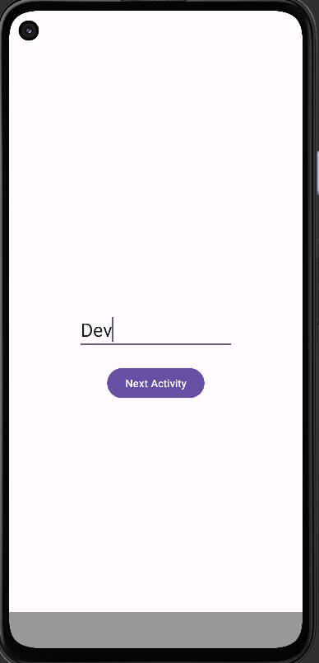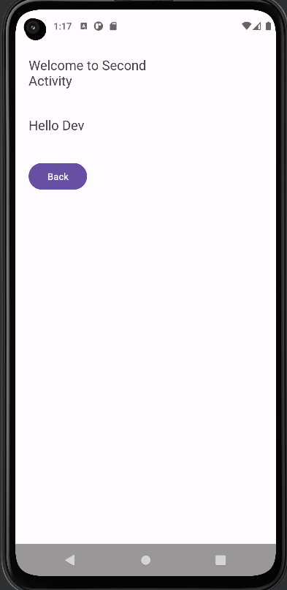

Q.10. Write android code to make a phone call using intent design proper UI.

Activity_main.xml

<?xml version="1.0" encoding="utf-8"?>  
<androidx.constraintlayout.widget.ConstraintLayout xmlns:android="http://schemas.android.com/apk/res/android"  
 xmlns:app="http://schemas.android.com/apk/res-auto"  
 xmlns:tools="http://schemas.android.com/tools"  
 android:layout_width="match_parent"  
 android:layout_height="match_parent"  
 tools:context=".MainActivity">  
  
 <TextView  
 android:id="@+id/textView"  
 android:layout_width="164dp"  
 android:layout_height="60dp"  
 android:layout_marginTop="108dp"  
 android:text="Make a Call"  
 android:textSize="25sp"  
 app:layout_constraintEnd_toEndOf="parent"  
 app:layout_constraintHorizontal_bias="0.546"  
 app:layout_constraintStart_toStartOf="parent"  
 app:layout_constraintTop_toTopOf="parent" />  
  
 <EditText  
 android:id="@+id/editTextNumber"  
 android:layout_width="wrap_content"  
 android:layout_height="wrap_content"  
 android:layout_marginTop="84dp"  
 android:ems="10"  
 android:hint="Type number with +91"  
 android:inputType="number"  
 app:layout_constraintEnd_toEndOf="parent"  
 app:layout_constraintHorizontal_bias="0.592"  
 app:layout_constraintStart_toStartOf="parent"  
 app:layout_constraintTop_toBottomOf="@+id/textView" />  
  
 <Button  
 android:id="@+id/button"  
 android:layout_width="wrap_content"  
 android:layout_height="wrap_content"  
 android:layout_marginTop="108dp"  
 android:text="Call"  
 app:layout_constraintEnd_toEndOf="parent"  
 app:layout_constraintHorizontal_bias="0.544"  
 app:layout_constraintStart_toStartOf="parent"  
 app:layout_constraintTop_toBottomOf="@+id/editTextNumber" />  
  
</androidx.constraintlayout.widget.ConstraintLayout>

MainActivity.java

package com.example.phonecallintent;  
import androidx.appcompat.app.AppCompatActivity;  
import android.content.Intent;  
import android.net.Uri;  
import android.os.Bundle;  
import android.view.View;  
import android.widget.Button;  
import android.widget.EditText;  
  
public class MainActivity extends AppCompatActivity {  
 Button btn;  
 EditText Phno;  
 @Override  
 protected void onCreate(Bundle savedInstanceState) {  
 super.onCreate(savedInstanceState);  
 setContentView(R.layout.*activity_main*);  
  
 btn= findViewById(R.id.*button*);  
 Phno = findViewById(R.id.*editTextNumber*);  
  
 btn.setOnClickListener(arg -> {  
  
 String phone_number = Phno.getText().toString();  
  
Intent phone_intent = new Intent(Intent.*ACTION_CALL*);  
  
phone_intent.setData(Uri.*parse*("tel:" + phone_number));  
  
startActivity(phone_intent);  
 });  
 }  
}

Output:

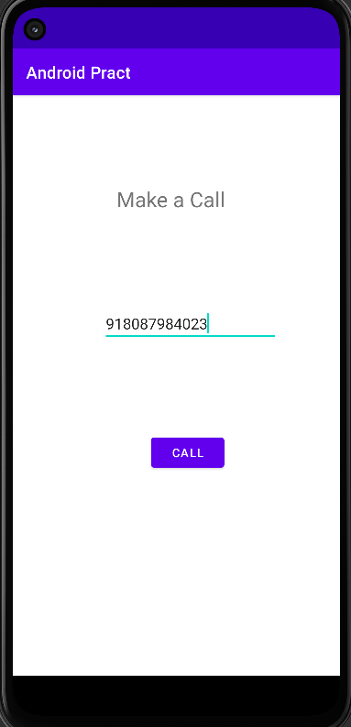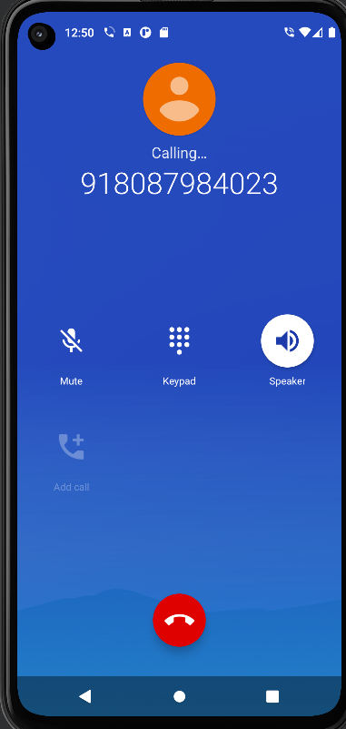

Q.11. Write an android application using SQLite to create table and perform CRUD operations (Example. COURSE table (ID, Name, Duration, Description), perform ADD, UPDATE, DELETE and READ operations)

#Activity_main.xml

<?xml version="1.0" encoding="utf-8"?>  
<LinearLayout xmlns:android="http://schemas.android.com/apk/res/android"  
 xmlns:app="http://schemas.android.com/apk/res-auto"  
 xmlns:tools="http://schemas.android.com/tools"  
 android:layout_width="match_parent"  
 android:layout_height="match_parent"  
 android:orientation="vertical"  
 tools:context=".MainActivity">  
  
 <EditText  
 android:id="@+id/c_id"  
 android:layout_width="match_parent"  
 android:layout_height="wrap_content"  
 android:hint="Course ID"  
 android:inputType="number" />  
  
 <EditText  
 android:id="@+id/c_name"  
 android:layout_width="match_parent"  
 android:layout_height="wrap_content"  
 android:hint="Course Name"  
 android:inputType="textPersonName" />  
  
 <EditText  
 android:id="@+id/c_duration"  
 android:layout_width="match_parent"  
 android:layout_height="wrap_content"  
 android:hint="Course Duration"  
 android:inputType="number" />  
  
 <EditText  
 android:id="@+id/c_description"  
 android:layout_width="match_parent"  
 android:layout_height="wrap_content"  
 android:layout_weight="0.1"  
 android:hint="Course Description"  
 android:inputType="textLongMessage" />  
  
 <Button  
 android:layout_width="wrap_content"  
 android:layout_height="wrap_content"  
 android:onClick="loadCourse"  
 android:layout_gravity="center"  
 android:text="Load All Course" />  
  
 <TextView  
 android:id="@+id/result"  
 android:layout_width="match_parent"  
 android:layout_height="0dp"  
 android:layout_weight="1"  
 android:hint="Result"  
 android:textSize="30dp" />  
  
 <LinearLayout  
 android:layout_width="match_parent"  
 android:layout_height="wrap_content"  
 android:orientation="horizontal">  
 <Button  
 android:layout_width="match_parent"  
 android:layout_height="wrap_content"  
 android:layout_weight="1"  
 android:onClick="addCourse"  
 android:text="ADD" />  
  
 <Button  
 android:layout_width="match_parent"  
 android:layout_height="wrap_content"  
 android:layout_weight="1"  
 android:onClick="updateCourse"  
 android:text="UPDATE" />  
  
 <Button  
 android:layout_width="match_parent"  
 android:layout_height="wrap_content"  
 android:layout_weight="1"  
 android:onClick="deleteCourse"  
 android:text="DELETE By Id" />  
 </LinearLayout>  
</LinearLayout>

MainActivity.java

package com.abhi.practsql;  
  
import androidx.appcompat.app.AppCompatActivity;  
  
import android.os.Bundle;  
import android.text.method.ScrollingMovementMethod;  
import android.view.View;  
import android.widget.EditText;  
import android.widget.TextView;  
  
public class MainActivity extends AppCompatActivity {  
 TextView resultText;  
 EditText courseId;  
 EditText courseDuration;  
 EditText courseDescription;  
 EditText courseName;  
 MyDBHandler dbHandler;  
  
 @Override  
 protected void onCreate(Bundle savedInstanceState) {  
 super.onCreate(savedInstanceState);  
 setContentView(R.layout.activity_main);  
 resultText = (TextView) findViewById(R.id.result);  
 courseId = (EditText) findViewById(R.id.c_id);  
 courseName = (EditText) findViewById(R.id.c_name);  
 courseDuration = (EditText) findViewById(R.id.c_duration);  
 courseDescription = (EditText) findViewById(R.id.c_description);  
 resultText.setMovementMethod(new ScrollingMovementMethod());  
 dbHandler = new MyDBHandler(this);  
 }  
  
 public void loadCourse(View view) {  
 resultText.setText(dbHandler.loadHandler());  
 courseId.setText("");  
 courseName.setText("");  
 courseDuration.setText("");  
 courseDescription.setText("");  
 }  
  
 public void addCourse(View view) {  
 if (!courseId.getText().toString().isEmpty() &&  
 !courseName.getText().toString().isEmpty() &&  
 !courseDuration.getText().toString().isEmpty() &&  
 !courseDescription.getText().toString().isEmpty())  
 {  
 int id = Integer.parseInt(courseId.getText().toString());  
 int duration = Integer.parseInt(courseDuration.getText().toString());  
 String name = courseName.getText().toString();  
 String desc = courseDescription.getText().toString();  
 Course course = new Course(id, name, duration, desc);  
 long insertId = dbHandler.addHandler(course);  
 if (insertId == -1) {  
 resultText.setText("Record already exists");  
 } else {  
 courseId.setText("");  
 courseName.setText("");  
 courseDuration.setText("");  
 courseDescription.setText("");  
 resultText.setText("Record added");  
 }  
 } else {  
 resultText.setText("Please fill correct details");  
 }  
 }  
  
 public void updateCourse(View view) {  
 if (!courseId.getText().toString().isEmpty() &&  
 !courseName.getText().toString().isEmpty() &&  
 !courseDuration.getText().toString().isEmpty() &&  
 !courseDescription.getText().toString().isEmpty())  
 {  
 boolean result = dbHandler.updateHandler(Integer.parseInt(courseId.getText().toString()), courseName.getText().toString(), Integer.parseInt(courseDuration.getText().toString()), courseDescription.getText().toString());  
 if (result) {  
 courseId.setText("");  
 courseName.setText("");  
 courseDuration.setText("");  
 courseDescription.setText("");  
 resultText.setText("Record Updated");  
 } else {  
 resultText.setText("No Record Found");  
 }  
 } else {  
 resultText.setText("Please fill correct id and name");  
 }  
 }  
 public void deleteCourse(View view) {  
 if (!courseId.getText().toString().isEmpty()) {  
 boolean result = dbHandler.deleteHandler(Integer.parseInt(courseId.getText().toString()));  
 if (result) {  
 courseId.setText("");  
 courseName.setText("");  
 courseDuration.setText("");  
 courseDescription.setText("");  
 resultText.setText("Record Deleted");  
 } else {  
 resultText.setText("No Record Found");  
 }  
 } else {  
 resultText.setText("Please fill correct id");  
 }  
 }  
  
 @Override  
 protected void onDestroy() {  
 super.onDestroy();  
 dbHandler.close();  
 }  
}

MyDBHandler.java

package com.abhi.practsql;  
import android.content.ContentValues;  
import android.content.Context;  
import android.database.Cursor;  
import android.database.sqlite.SQLiteDatabase;  
import android.database.sqlite.SQLiteOpenHelper;  
  
public class MyDBHandler extends SQLiteOpenHelper {  
 private static final int DATABASE_VERSION = 1;  
 private static final String DATABASE_NAME = "courseDB.db";  
 private static final String TABLE_COURSE = "course";  
 private static final String COLUMN_ID = "CourseID";  
 private static final String COLUMN_NAME = "CourseName";  
 private static final String COLUMN_DUR = "CourseDuration";  
 private static final String COLUMN_DESC = "CourseDescription";  
  
 MyDBHandler(Context context) {  
 super(context, DATABASE_NAME, null, DATABASE_VERSION);  
 }  
  
 @Override  
 public void onCreate(SQLiteDatabase db) {  
 String CREATE_COURSE_TABLE = "CREATE TABLE " + TABLE_COURSE + "(" +  
 COLUMN_ID + " INTEGER PRIMARY KEY," +  
 COLUMN_NAME + " TEXT," +  
 COLUMN_DUR + " TEXT," +  
 COLUMN_DESC + " TEXT" +  
 ")";  
 db.execSQL(CREATE_COURSE_TABLE);  
 }  
  
 @Override  
 public void onUpgrade(SQLiteDatabase db, int oldVersion, int newVersion) {  
 db.execSQL("DROP TABLE IF EXISTS " + TABLE_COURSE);  
 onCreate(db);  
 }  
  
 String loadHandler() {  
 String result = "";  
 String query = "SELECT * FROM " + TABLE_COURSE;  
 SQLiteDatabase db = this.getReadableDatabase();  
 Cursor cursor = db.rawQuery(query, null);  
  
 while (cursor.moveToNext()) {  
 int result_0 = cursor.getInt(cursor.getColumnIndex(COLUMN_ID));  
 String result_1 = cursor.getString(cursor.getColumnIndex(COLUMN_NAME));  
 String result_2 = cursor.getString(cursor.getColumnIndex(COLUMN_DUR));  
 String result_3 = cursor.getString(cursor.getColumnIndex(COLUMN_DESC));  
  
 result += "ID: " + result_0 + "\nName: " + result_1 + "\nDuration: " + result_2 + "\nDescription: " + result_3 + "\n\n";  
 }  
  
 cursor.close();  
 db.close();  
  
 if (result.isEmpty()) {  
 result = "No Records Found";  
 }  
  
 return result;  
 }  
 long addHandler(Course course) {  
 long id;  
 ContentValues values = new ContentValues();  
 values.put(COLUMN_ID, course.getID());  
 values.put(COLUMN_NAME, course.getCourseName());  
 values.put(COLUMN_DUR, course.getDur());  
 values.put(COLUMN_DESC, course.getDesc());  
 SQLiteDatabase db = this.getWritableDatabase();  
 id = db.insert(TABLE_COURSE, null, values);  
 db.close();  
 return id;  
 }  
  
 boolean updateHandler(int ID, String name, int dur, String desc) {  
 SQLiteDatabase db = this.getWritableDatabase();  
 ContentValues args = new ContentValues();  
  
 args.put(COLUMN_ID, ID);  
 args.put(COLUMN_NAME, name);  
 args.put(COLUMN_DUR, dur);  
 args.put(COLUMN_DESC, desc);  
 return db.update(TABLE_COURSE, args, COLUMN_ID + "=" + ID, null) > 0;  
 }  
 boolean deleteHandler(int ID) {  
 boolean result = false;  
 String query = "Select*FROM " + TABLE_COURSE + " WHERE " + COLUMN_ID + " = '" + ID + "'";  
 SQLiteDatabase db = this.getWritableDatabase();  
 Cursor cursor = db.rawQuery(query, null);  
 Course course = new Course();  
 if (cursor.moveToFirst()) {  
 course.setID(Integer.parseInt(cursor.getString(0)));  
 db.delete(TABLE_COURSE, COLUMN_ID + "=?", new String[]{String.valueOf(course.getID())  
 });  
 cursor.close();  
 result = true;  
 }  
 db.close();  
 return result;  
 }  
}

Course.java

package com.abhi.practsql;  
  
public class Course {  
  
 private int id;  
 private String courseName;  
  
 private int dur;  
 private String desc;  
  
 Course() {  
 }  
 Course(int id, String courseName, int dur, String desc) {  
 this.id = id;  
 this.dur = dur;  
 this.courseName = courseName;  
 this.desc = desc;  
 }  
 void setID(int id) {  
 this.id = id;  
 }  
 int getID() {  
 return this.id;  
 }  
 void setCourseName(String coursename) {  
 this.courseName = coursename;  
  
 }  
 String getCourseName() { return  
 this.courseName;  
 }  
  
 public int getDur() {  
 return dur;  
 }  
  
 public void setDur(int dur) {  
 this.dur = dur;  
 }  
  
 public String getDesc() {  
 return desc;  
 }  
  
 public void setDesc(String desc) {  
 this.desc = desc;  
 }  
}

Output:

ADD and READ  
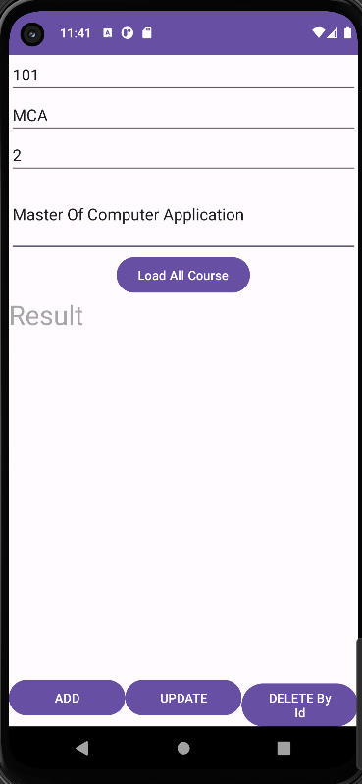 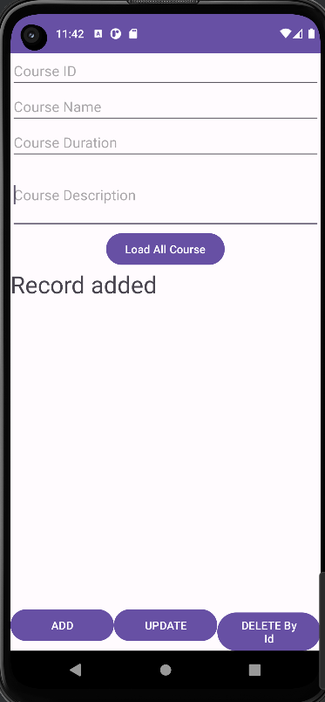 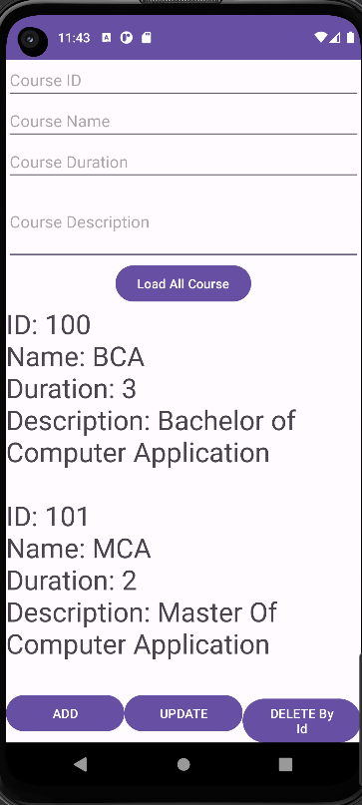

UPDATE and READ

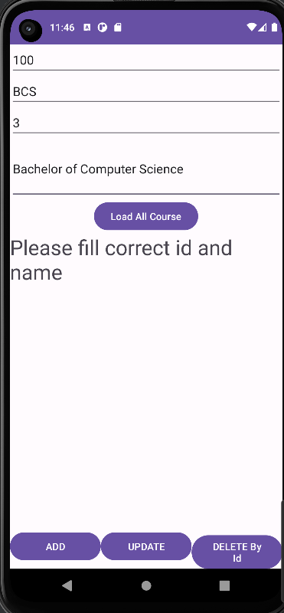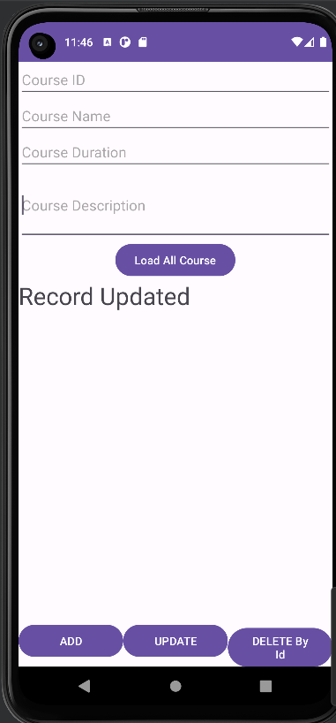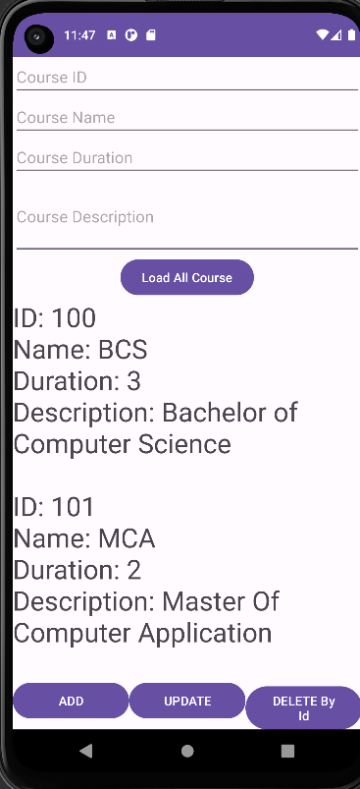

DELETE and READ

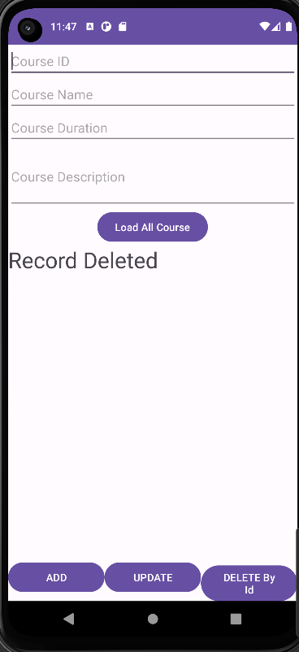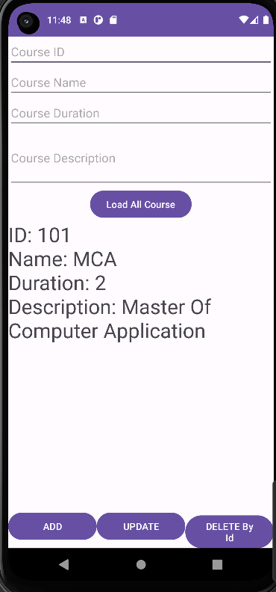

Q.12. Create an Android app to manage STUDENT data, powered by Firebase Realtime database that supports: Adding Data to Firebase Realtime database, Retrieving Data from Firebase, Update a record and Deleting data from firebase data.

#Activity_main.xml

<?xml version="1.0" encoding="utf-8"?>  
<LinearLayout xmlns:android="http://schemas.android.com/apk/res/android"  
 xmlns:app="http://schemas.android.com/apk/res-auto"  
  
 xmlns:tools="http://schemas.android.com/tools"  
 android:layout_width="match_parent"  
 android:layout_height="match_parent"  
 android:layout_margin="10dp"  
 android:orientation="vertical"  
 tools:context=".MainActivity">  
  
 <TextView  
 android:layout_width="match_parent"  
 android:layout_height="wrap_content"  
 android:gravity="center_horizontal"  
 android:text="Student Details"  
 android:textSize="20sp" />  
  
 <EditText  
 android:id="@+id/stdId"  
 android:layout_width="match_parent"  
 android:layout_height="wrap_content"  
 android:hint="Enter Student ID" />  
  
 <EditText  
 android:id="@+id/stdName"  
 android:layout_width="match_parent"  
 android:layout_height="wrap_content"  
 android:hint="Enter Student Name" />  
  
 <EditText  
 android:id="@+id/stdAdd"  
 android:layout_width="match_parent"  
 android:layout_height="wrap_content"  
 android:hint="Enter Student Address" />  
  
 <EditText  
 android:id="@+id/stdPhno"  
 android:layout_width="match_parent"  
 android:layout_height="wrap_content"  
 android:hint="Enter Student Phone number" />  
  
 <LinearLayout  
 android:layout_width="match_parent"  
 android:layout_height="wrap_content"  
 android:orientation="horizontal">  
  
 <Button  
 android:id="@+id/btnSave"  
 android:layout_width="wrap_content"  
 android:layout_height="wrap_content"  
 android:onClick="save"  
 android:text="Save" />  
  
 <Button  
 android:id="@+id/btnShow"  
 android:layout_width="wrap_content"  
 android:layout_height="wrap_content"  
 android:layout_marginLeft="3dp"  
 android:onClick="show"  
 android:text="Show" />  
  
 <Button  
 android:id="@+id/btnUpdate"  
  
 android:layout_width="wrap_content"  
 android:layout_height="wrap_content"  
 android:layout_marginLeft="3dp"  
 android:onClick="update"  
 android:text="Update" />  
  
 <Button  
 android:id="@+id/btnDelete"  
 android:layout_width="wrap_content"  
 android:layout_height="wrap_content"  
 android:layout_marginLeft="3dp"  
 android:onClick="delete"  
 android:text="Delete" />  
 </LinearLayout>  
</LinearLayout>

MainActivity.java

package com.abhi.firebasecurd;  
  
import androidx.annotation.NonNull;  
import androidx.appcompat.app.AppCompatActivity;  
  
import android.os.Bundle;  
import android.text.TextUtils;  
import android.view.View;  
import android.widget.EditText;  
import android.widget.Toast;  
  
import com.google.firebase.database.DataSnapshot;  
import com.google.firebase.database.DatabaseError;  
import com.google.firebase.database.DatabaseReference;  
import com.google.firebase.database.FirebaseDatabase;  
import com.google.firebase.database.ValueEventListener;  
  
public class MainActivity extends AppCompatActivity {  
 EditText txtId, txtName, txtAdd, txtphno;  
 DatabaseReference dbref;  
 Student std;  
 String id, name, add, phno;  
  
 @Override  
 protected void onCreate(Bundle savedInstanceState) {  
 super.onCreate(savedInstanceState);  
 setContentView(R.layout.activity_main);  
 txtId = findViewById(R.id.stdId);  
 txtName = findViewById(R.id.stdName);  
 txtAdd = findViewById(R.id.stdAdd);  
 txtphno = findViewById(R.id.stdPhno);  
 std = new Student();  
 }  
  
 public void save(View view) {  
 id = txtId.getText().toString();  
 name = txtName.getText().toString();  
 add = txtAdd.getText().toString();  
 phno = txtphno.getText().toString();  
//Code to Save the employee details  
 dbref = FirebaseDatabase.getInstance().getReference().child("Student");  
 try {  
 if (TextUtils.isEmpty(txtId.getText().toString()))  
 Toast.makeText(getApplicationContext(), "Please enter ID", Toast.LENGTH_LONG).show();  
 else if (TextUtils.isEmpty(txtName.getText().toString()))  
 Toast.makeText(getApplicationContext(), "Please enter Name", Toast.LENGTH_LONG).show();  
 else if (TextUtils.isEmpty(txtphno.getText().toString()))  
 Toast.makeText(getApplicationContext(), "Please enter Phone Number",  
 Toast.LENGTH_LONG).show();  
 else {  
 std.setID(id);  
 std.setName(name);  
 std.setAddress(add);  
 std.setPhno(phno);  
//insert details in db.  
 dbref.child(id).setValue(std);  
 Toast.makeText(getApplicationContext(), "Record Added", Toast.LENGTH_LONG).show();  
 txtId.setText("");  
 txtName.setText("");  
 txtAdd.setText("");  
 txtphno.setText("");  
 }  
 } catch (Exception e) {  
 e.printStackTrace();  
 }  
 }  
 //Code to Display a Record  
 public void show(View view) {  
 id = txtId.getText().toString();  
 dbref = FirebaseDatabase.getInstance().getReference().child("Student").child(id);  
 dbref.addListenerForSingleValueEvent(new ValueEventListener() {  
 @Override  
 public void onDataChange(@NonNull DataSnapshot snapshot) {  
 if (snapshot.hasChildren()) {  
 txtId.setEnabled(false);  
 txtName.setText(snapshot.child("name").getValue().toString());  
 txtAdd.setText(snapshot.child("address").getValue().toString());  
 txtphno.setText(snapshot.child("phno").getValue().toString());  
 } else {  
 Toast.makeText(getApplicationContext(), "No data to display", Toast.LENGTH_LONG).show();  
 }  
 }  
  
 @Override  
 public void onCancelled(@NonNull DatabaseError error) {  
 }  
 });  
 }  
 //Code to update a Record  
 public void update(View view) {  
 id = txtId.getText().toString();  
 dbref = FirebaseDatabase.getInstance().getReference().child("Student").child(id);  
 dbref.addListenerForSingleValueEvent(new ValueEventListener() {  
 @Override  
 public void onDataChange(@NonNull DataSnapshot snapshot) {  
 if (snapshot.hasChildren()) {  
 std.setName(txtName.getText().toString().trim());  
  
 std.setAddress(txtAdd.getText().toString().trim());  
 std.setPhno(txtphno.getText().toString().trim());  
 dbref.setValue(std);  
 Toast.makeText(getApplicationContext(), "Data Updated", Toast.LENGTH_LONG).show();  
 } else {  
 Toast.makeText(getApplicationContext(), "No data to update", Toast.LENGTH_LONG).show();  
 }  
 }  
  
 @Override  
 public void onCancelled(@NonNull DatabaseError error) {  
 }  
 });  
 }  
 //Code to delete a Record  
 public void delete(View view) {  
 id = txtId.getText().toString();  
 dbref = FirebaseDatabase.getInstance().getReference().child("Student").child(id);  
 dbref.addListenerForSingleValueEvent(new ValueEventListener() {  
 @Override  
 public void onDataChange(@NonNull DataSnapshot snapshot) {  
 if (snapshot.hasChildren()) {  
 dbref.removeValue();  
 Toast.makeText(getApplicationContext(), "Record Deleted", Toast.LENGTH_LONG).show();  
 } else {  
 Toast.makeText(getApplicationContext(), "No such record", Toast.LENGTH_LONG).show();  
 }  
 }  
 @Override  
 public void onCancelled(@NonNull DatabaseError error) {  
 }  
 });  
  
 }  
}

Student.java

package com.abhi.firebasecurd;  
  
public class Student {  
 private String ID;  
 private String name;  
 private String address;  
 private String phno;  
  
 public String getID() {  
 return ID;  
 }  
  
 public void setID(String ID) {  
 this.ID = ID;  
 }  
  
 public String getName() {  
 return name;  
 }  
  
 public void setName(String name) {  
 this.name = name;  
 }  
  
 public String getAddress() {  
 return address;  
 }  
  
 public void setAddress(String address) {  
 this.address = address;  
 }  
  
 public String getPhno() {  
 return phno;  
 }  
  
 public void setPhno(String phno) {  
 this.phno = phno;  
 }  
  
}

Output

**ADD**

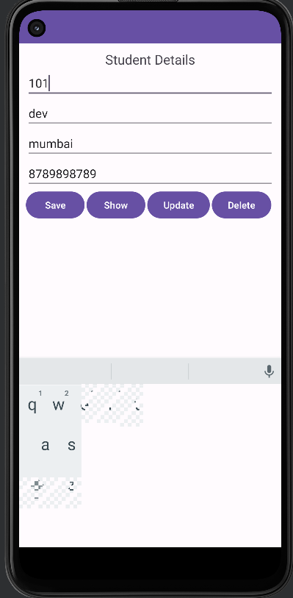 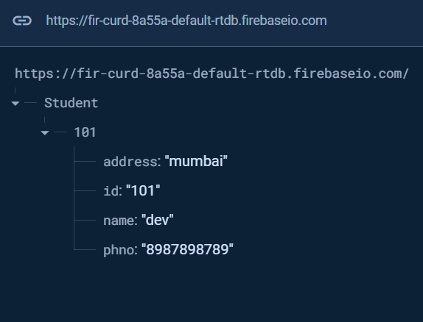

**UPDATE**

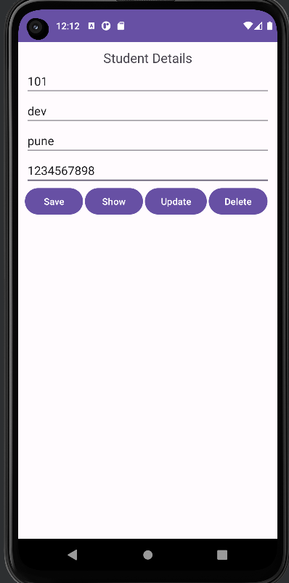 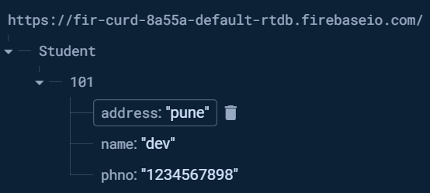

**DELETE**

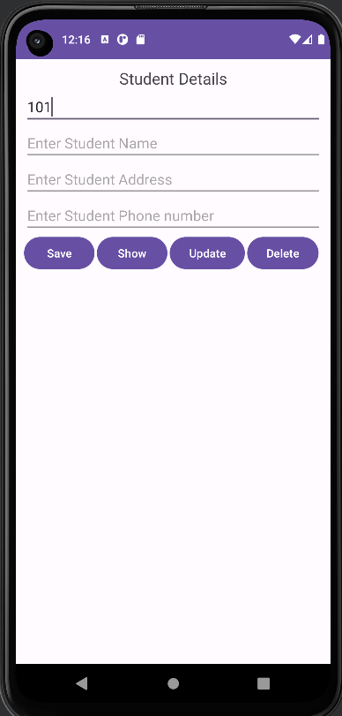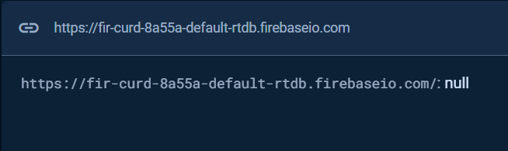

READ

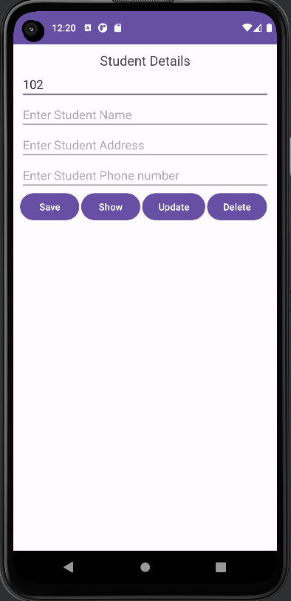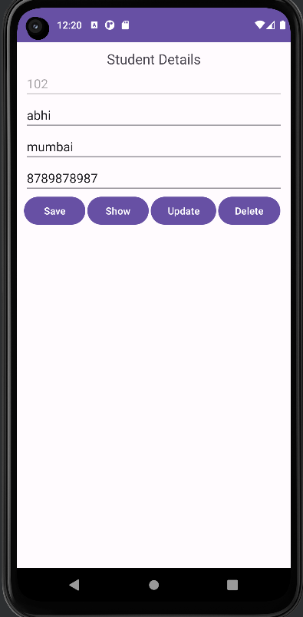

Q.13. Write an android app to write JSON data into a file and read JSON data from created file.

Activity_main.xml

<?xml version="1.0" encoding="utf-8"?>  
<LinearLayout xmlns:android="http://schemas.android.com/apk/res/android"  
 xmlns:app="http://schemas.android.com/apk/res-auto"  
 xmlns:tools="http://schemas.android.com/tools"  
 android:layout_width="match_parent"  
 android:layout_height="match_parent"  
 android:layout_margin="10dp"  
 android:orientation="vertical"  
 tools:context=".MainActivity">  
  
 <TextView  
 android:layout_width="match_parent"  
 android:layout_height="wrap_content"  
 android:gravity="center_horizontal"  
 android:text="Employee Details"  
 android:textSize="20sp" />  
  
 <EditText  
 android:id="@+id/empId"  
 android:layout_width="match_parent"  
 android:layout_height="wrap_content"  
 android:hint="Enter Employee ID" />  
  
 <EditText  
 android:id="@+id/empName"  
 android:layout_width="match_parent"  
 android:layout_height="wrap_content"  
 android:hint="Enter Employee Name" />  
  
 <EditText  
 android:id="@+id/empAdd"  
 android:layout_width="match_parent"  
 android:layout_height="wrap_content"  
 android:hint="Enter Employee Address" />  
  
 <EditText  
 android:id="@+id/empPhno"  
 android:layout_width="match_parent"  
 android:layout_height="wrap_content"  
 android:hint="Enter Employee Phonenumber" />  
  
 <LinearLayout  
 android:layout_width="match_parent"  
 android:layout_height="wrap_content"  
 android:orientation="horizontal">  
  
 <Button  
 android:id="@+id/btnSave"  
 android:layout_width="wrap_content"  
 android:layout_height="wrap_content"  
 android:onClick="save"  
 android:text="Save" />  
  
 <Button  
 android:id="@+id/btnShow"  
 android:layout_width="wrap_content"  
 android:layout_height="wrap_content"  
 android:layout_marginLeft="3dp"  
 android:onClick="show"  
 android:text="Show" />  
 </LinearLayout>  
 <TextView  
 android:id="@+id/details"  
 android:layout_width="wrap_content"  
 android:layout_height="wrap_content"  
 android:text="" />  
</LinearLayout>

MainActivity.java

package com.abhi.jsondata;  
  
import android.os.Bundle;  
import android.view.View;  
import android.widget.EditText;  
import android.widget.TextView;  
import androidx.appcompat.app.AppCompatActivity;  
import org.json.JSONException;  
import org.json.JSONObject;  
import java.io.BufferedReader;  
import java.io.BufferedWriter;  
import java.io.File;  
import java.io.FileNotFoundException;  
import java.io.FileReader;  
import java.io.FileWriter;  
import java.io.IOException;  
  
public class MainActivity extends AppCompatActivity {  
  
 EditText txtId, txtName, txtAdd, txtphno;  
 String id, name, add, phno;  
 String FILE_NAME = "Employee_data";  
 File file;  
 FileWriter fileWriter;  
 @Override  
 protected void onCreate(Bundle savedInstanceState) {  
 super.onCreate(savedInstanceState);  
 setContentView(R.layout.activity_main);  
 txtId = findViewById(R.id.empId);  
 txtName = findViewById(R.id.empName);  
 txtAdd = findViewById(R.id.empAdd);  
 txtphno = findViewById(R.id.empPhno);  
 // Define the File Path and its Name  
 file = new File(getApplicationContext().getFilesDir(), FILE_NAME);  
 try {  
 fileWriter = new FileWriter(file, true);  
 } catch (IOException e) {  
 e.printStackTrace();  
 }  
 }  
 public void save(View view) {  
 id = txtId.getText().toString();  
 name = txtName.getText().toString();  
 add = txtAdd.getText().toString();  
 phno = txtphno.getText().toString();  
 JSONObject jsonObject = new JSONObject();  
 try {  
 jsonObject.put("empid", id);  
 jsonObject.put("empname", name);  
 jsonObject.put("empadd", add);  
 jsonObject.put("empphno", phno);  
 } catch (JSONException e) {  
 e.printStackTrace();  
 }  
 String userString = jsonObject.toString();  
 try {  
 BufferedWriter bufferedWriter = new BufferedWriter(fileWriter);  
 bufferedWriter.write(userString);  
 bufferedWriter.close();  
 } catch (IOException e) {  
 e.printStackTrace();  
 }  
 txtId.setText("");  
 txtName.setText("");  
 txtAdd.setText("");  
 txtphno.setText("");  
 }  
 public void show(View view) {  
 TextView showdetails = findViewById(R.id.details);  
 StringBuilder stringBuilder;  
 FileReader fileReader = null;  
 try {  
 fileReader = new FileReader(file);  
 BufferedReader bufferedReader = new BufferedReader(fileReader);  
 stringBuilder = new StringBuilder();  
 String line = bufferedReader.readLine();  
 while (line != null) {  
 stringBuilder.append(line).append("\n");  
 line = bufferedReader.readLine();  
 }  
 bufferedReader.close();  
 String response = stringBuilder.toString();  
 showdetails.setText(response);  
 } catch (FileNotFoundException e) {  
 e.printStackTrace();  
 } catch (IOException e) {  
 e.printStackTrace();  
 }  
 }  
}

Output

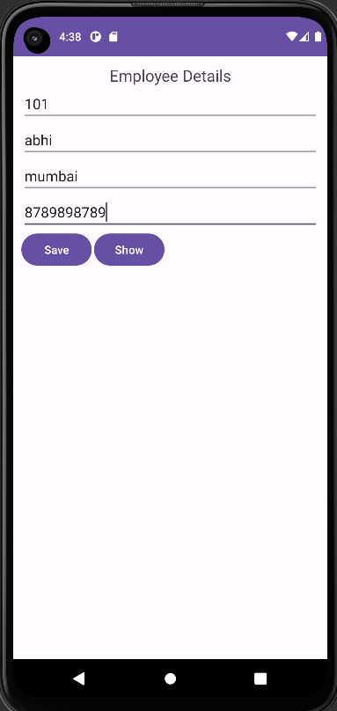 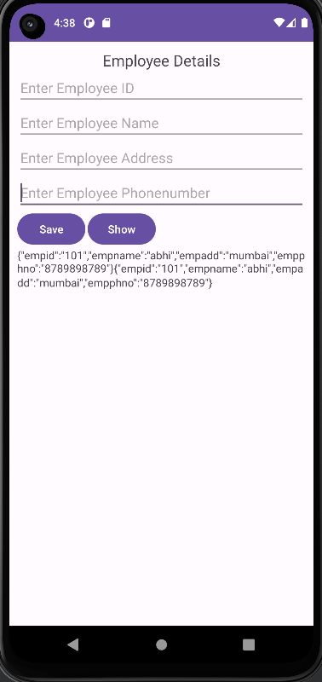

Q.14. Write a React Native application, to display a welcome screen with ‘Welcome to React Native’ message.

App.js

import React from 'react';

import { View, Text, StyleSheet } from 'react-native';

export default function App() {

return (

<View style={styles.container}>

<Text style={styles.welcomeText}>Welcome to React Native</Text>

</View>

);

}

const styles = StyleSheet.create({

container: {

flex: 1,

justifyContent: 'center',

alignItems: 'center',

backgroundColor: '#fff',

},

welcomeText: {

fontSize: 20,

textAlign: 'center',

margin: 10,

},

});

Output:

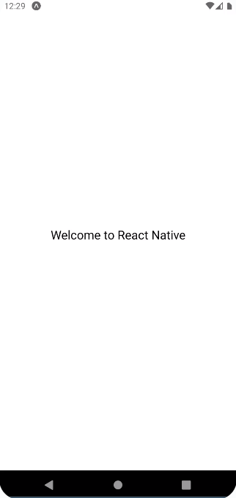

Q.15. Write a Flutter application, to display a ‘Hello World’ message.

Main.dart

import 'package:flutter/material.dart';  
  
void main() {  
 runApp(MyApp());  
}  
  
class MyApp extends StatelessWidget {  
 @override  
 Widget build(BuildContext context) {  
 return MaterialApp(  
 home: Scaffold(  
 appBar: AppBar(  
 title: Text('Hello World App'),  
 ),  
 body: Center(  
 child: Text(  
 'Hello World!',  
 style: TextStyle(fontSize: 24),  
 ),  
 ),  
 ),  
 );  
 }  
}

Output:

